**LEBANESE AMERICAN UNIVERSITY**

**USAID – HIGHER EDUCATION SCHOLARSHIP PROGRAM**

**HES - Volunteering Program Verification Form**

This form is to be used to document volunteering hours. If a student volunteers for multiple organizations, a separate form must be used for each organization. **This form must be turned in by the 28th of each month, the latest.**

I certify that the scholar Adnan Moumneh completed a total of 5 hours of service at Life Sculptor.

The hours were completed hours as per the below:

Hours # 2 (date) _02/09 - 06/09_ (initials of supervisor) __A.K.___

Hours # 1 (date) _09/09 – 13/09_ (initials of supervisor) __A.K.___

Hours # 1 date) _16/09 – 20/09 (initials of supervisor) __A.K.___

Hours # 1 date) _23/09 – 27/09 (initials of supervisor) __A.K.___

Brief description of the activities the scholar performed or participated in:

I did 5 comprehensive research tasks: Here are the topics with their sub topics (main ideas):  
  
1- Impact of Technology  
Digital Economy Growth: Overview of the rise of e-commerce and digital platforms in Arab economies.  
Role of Technology in Logistics: Innovations in supply chain management and their impact on trade efficiency.  
Fintech Development: Examination of how financial technology can facilitate cross-border transactions and reduce  
costs.  
  
2- Policy Recommendations  
Harmonizing Regulations and Standards: Suggested frameworks for aligning trade regulations among member states.  
Investment in Infrastructure: Priorities for investment in transport, logistics, and digital infrastructure to support trade.  
Incentives for Businesses: Recommendations for tax incentives and support programs to encourage cross-border  
investment and trade.  
Strengthening Institutions: Enhancing the role of the Arab League and other regional bodies in facilitating economic  
cooperation.  
  
3-Future Prospects  
Emerging Trends in Global Trade: Predictions on how shifts in global economic power may influence Arab trade  
relations.  
Potential for New Markets: Discussion on the opportunities presented by emerging economies in Africa and Asia for  
Arab trade.  
  
4-Sustainable Development Goals (SDGs): Alignment of trade and economic integration efforts with the UN’s SDGs,  
particularly in promoting sustainable economic growth.  
  
5-Case Studies  
Notable Collaborations: Detailed analysis of specific successful trade agreements, including participant states and  
economic impacts.  
Sector-Specific Initiatives: Examples of collaborations in sectors like renewable energy, tourism, or education that  
illustrate the potential for further integration.

Written feedback about the scholar’s performance:

Adnan Momneh demonstrated strong research skills, a proactive approach, and dedication, delivering thorough and well-organized information and insights for Life Sculptor.

Please rate the overall performance of the scholar at your organization:

|  |  |  |  |
| --- | --- | --- | --- |
|  | Mastery (5) | Proficient (3) | Emerging (1) |
| **Problem solver** | X |  |  |
| **Engaged & Committed** | X |  |  |
| **Open-minded & multicultural** | X |  |  |

Signature

& stamp

__________________________

_

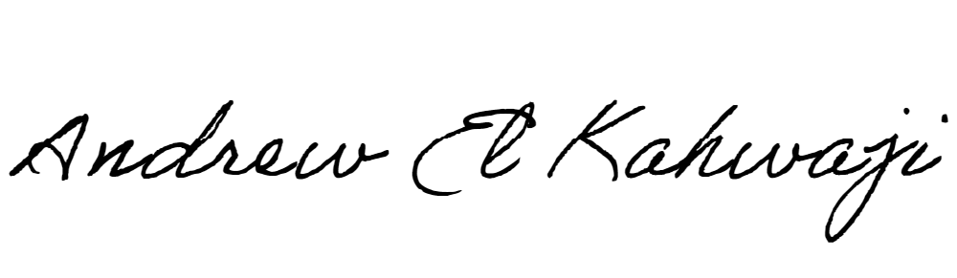

Printed Name _Andrew El Kahwaji_

Date __25/09/2024___

Email __andrew.lifesculptor.coo@gmail.com __

Phone __+961 71 914 378__

**LEBANESE AMERICAN UNIVERSITY**

**USAID – HIGHER EDUCATION SCHOLARSHIP PROGRAM**

